|  |  |
| --- | --- |
| Unit 2: Service Strategy | [previous](https://w3-01.sso.ibm.com/learning/lms/content/content_store/cninv000000000027872/site/unit_1/summary.htm)spacer[next](https://w3-01.sso.ibm.com/learning/lms/content/content_store/cninv000000000027872/site/unit_2/lesson_1/index.html) |

|  |
| --- |
| Introduction In this Unit, you will learn more about Service Strategy. Unit Objectives By the end of this unit, you should be able to:   * Explain the purpose of Service Strategy * Explain the two elements of value: utility and warranty * Describe the three types of service providers * Explain how to choose between service provider types * Describe the key principles of Service Strategy * Discuss the main Service Strategy processes and associated activities |
| Lesson 1: Service Strategy Overview | [previous](https://w3-01.sso.ibm.com/learning/lms/content/content_store/cninv000000000027872/site/unit_2/index.html)spacer[next](https://w3-01.sso.ibm.com/learning/lms/content/content_store/cninv000000000027872/site/unit_2/lesson_1/sec01.htm) |

|  |
| --- |
| In this lesson, you will learn more about the purpose of and concepts relating to Service Strategy. |

|  |  |
| --- | --- |
| Service Strategy Defined | [previous](https://w3-01.sso.ibm.com/learning/lms/content/content_store/cninv000000000027872/site/unit_2/lesson_1/index.html)spacer[next](https://w3-01.sso.ibm.com/learning/lms/content/content_store/cninv000000000027872/site/unit_2/lesson_1/sec02.htm) |

|  |
| --- |
| This graphic represents ITIL Service Lifecycle focusing on Service Strategy.***Service Strategy*** is a strategic plan designed to achieve defined objectives.  A healthy business model will describe the defined objectives of the business. A clear strategy for accomplishing the objectives must be clearly stated to the customer. Otherwise, the customer will not recognize the increase in value. The Service Strategy defines a clear path to delivering value to the customer.  Customers are looking for ways to strategically improve their business models. They want solutions that will break through existing performance barriers. They want to increase performance without an increase in cost. This kind of improvement provides an opportunity to offer a solution by providing improved products and services |

|  |  |
| --- | --- |
| Purpose of Service Strategy | [previous](https://w3-01.sso.ibm.com/learning/lms/content/content_store/cninv000000000027872/site/unit_2/lesson_1/sec01.htm)spacer[next](https://w3-01.sso.ibm.com/learning/lms/content/content_store/cninv000000000027872/site/unit_2/lesson_1/sec03.htm) |

|  |
| --- |
| Business needs and requirements should be the driving force behind all service solutions and activities. In addition, Service Strategy must also reflect the strategies and policies of the service provider organization.  Service Strategy consists of:   * Strategies * Policies * Resources and Constraints * Service Level Package (SLP) from Requirements   The key to any successful Service Strategy is to focus on fully satisfying the customer's needs at a sufficient value to the customer.  Service providers must be able to think and act in a strategic manner.   * The achievement of strategic goals or objectives requires the use of strategic assets. * Service Strategy shows how to transform Service Management into a strategic asset. * Technical knowledge of IT is necessary but not sufficient. * Strategy requires knowledge from the disciplines such as operations management, marketing, finance, information systems, organizational development, systems dynamics, and industrial engineering. |

|  |  |
| --- | --- |
| Service Strategy Objectives | [previous](https://w3-01.sso.ibm.com/learning/lms/content/content_store/cninv000000000027872/site/unit_2/lesson_1/sec02.htm)spacer[next](https://w3-01.sso.ibm.com/learning/lms/content/content_store/cninv000000000027872/site/unit_2/lesson_1/sec04.htm) |

|  |
| --- |
| Service Strategy seeks to answer the questions:   * What services should be offered and to whom? * How do we differentiate ourselves from competing alternatives? * How do we truly create value for our customers? * How do we capture value for our stakeholders? * How can we make a case for strategic investments? * How can financial management provide visibility and control over value creation? * How should we define service quality? * How do we choose among different paths for improving service quality? * How do we efficiently allocate resources throughout a portfolio of services? * How do we resolve conflicting demands for shared resources? |

|  |  |
| --- | --- |
| Service Model | [previous](https://w3-01.sso.ibm.com/learning/lms/content/content_store/cninv000000000027872/site/unit_2/lesson_1/sec03.htm)spacer[next](https://w3-01.sso.ibm.com/learning/lms/content/content_store/cninv000000000027872/site/unit_2/lesson_1/sec05.htm) |

|  |
| --- |
| Service Models describe the structure and dynamics of a service. Service models are blueprints for service management processes and functions to communicate and collaborate on value creation. Service Models describe how service assets interact with customer assets and create value for a given portfolio of contracts. The purpose of the Service Model is to define the value to be created in the form of the utility and the warranty provided to customers.  A Service Model performs the following tasks:   * Codifies the Service Strategy for a market space. * Designs and records processes and functions needed to create value. * Describes how service assets create value for a given portfolio of contracts. * Is useful for effectiveness in Continual Service Improvement.   Service Agreements specify the terms and conditions under which such interaction occurs with commitments and expectations on each side.  **Note**: ***Interaction*** means demand connects with the capacity to serve.  Service Transition evaluates the options or paths for improvements and recommends solutions that are cost-effective and low risk.  Service Models continually evolve, based on external feedback received from customers and internal feedback from Service Management processes.  Continual Service Improvement (CSI) processes ensure the feedback to the strategy, design, transition, and operation processes. Improvements can be made to the structure, the dynamics of a model, or to both. |

|  |  |
| --- | --- |
| Business Case | [previous](https://w3-01.sso.ibm.com/learning/lms/content/content_store/cninv000000000027872/site/unit_2/lesson_1/sec04.htm)spacer[next](https://w3-01.sso.ibm.com/learning/lms/content/content_store/cninv000000000027872/site/unit_2/lesson_1/sec06.htm) |

|  |  |  |  |  |  |  |  |  |  |  |  |  |  |  |
| --- | --- | --- | --- | --- | --- | --- | --- | --- | --- | --- | --- | --- | --- | --- |
| A Business Case is a decision support and planning tool that projects the likely consequences of a business action.  The consequences can take on qualitative and quantitative dimensions. A financial analysis, for example, is frequently central to a good business case.   |  |  | | --- | --- | | **Business Case Structure** | | | **Element** | **Description** | | Introduction | Presents the business objectives addressed by the service management initiative | | Methods and Assumptions | Defines the boundaries of the business case, such as time period | | Business Impacts | The financial and nonfinancial business case results | | Risks and Contingencies | The probability that alternative results will engage | | Recommendations | Specific actions recommended | |

|  |  |
| --- | --- |
| Elements of Value: Utility and Warranty | [previous](https://w3-01.sso.ibm.com/learning/lms/content/content_store/cninv000000000027872/site/unit_2/lesson_1/sec05.htm)spacer[next](https://w3-01.sso.ibm.com/learning/lms/content/content_store/cninv000000000027872/site/unit_2/lesson_1/sec07.htm) |

|  |
| --- |
| Customers cannot benefit from something that is fit for purpose but not fit for use, or vice versa. You will find it useful to separate the logic of utility from the logic of warranty for the purpose of design, development, and improvement. Considering all the separate controllable inputs, Service Strategy leads to a wider range of solutions to the problem of creating, maintaining, and increasing value.   * **Utility**: Attributes of the service that have a positive effect on the performance of activities, objects, and tasks associated with required outcomes. * **Warranty**: The positive effect being available when needed, in sufficient capacity or magnitude, and dependably in terms of continuity and security. |

**Note**: Utility is what the customer gets, and warranty is how it is delivered

|  |  |
| --- | --- |
| The Four Ps of Service Strategy | [previous](https://w3-01.sso.ibm.com/learning/lms/content/content_store/cninv000000000027872/site/unit_2/lesson_1/sec06.htm)spacer[next](https://w3-01.sso.ibm.com/learning/lms/content/content_store/cninv000000000027872/site/unit_2/lesson_1/sec08.htm) |

|  |
| --- |
| A service provider must have a solid good understanding of its service objectives and what makes it distinctive. Then, it is ready to begin the service lifecycle. The entry points to Service Strategy are referred to as the Four Ps. These points identify the different forms a Service Strategy can take.   1. **Perspective**: Describes a vision and direction 2. **Position**: Describes the decision to adopt a well-defined stance 3. **Plan**: Describes the means of moving from the current situation to the future one 4. **Pattern**: Describes a series of consistent decisions and actions over time   A strategic perspective articulates the business philosophy and manner in which services are provided. CIOs might determine that their businesses most value a certain type of service provider.  An internal service provider (Type I) restricted to serving one business unit might adopt a position based on any one of the following factors:   * Product knowledge * Customer responsiveness * Value * Cost * Specialized services * Broad sets of services   Planning the transition requires answering questions such as:   * How do we offer high-value or low-cost services? * How do we achieve and offer our specialized services?   Patterns might be:   * A service provider who continually offers specific services with deep expertise is adopting a high-value or high-end Service Strategy. * A service provider who continually offers dependable and reliable services is adopting a high-warranty strategy. |

|  |  |
| --- | --- |
| Service Automation | [previous](https://w3-01.sso.ibm.com/learning/lms/content/content_store/cninv000000000027872/site/unit_2/lesson_1/sec07.htm)spacer[next](https://w3-01.sso.ibm.com/learning/lms/content/content_store/cninv000000000027872/site/unit_2/lesson_2/index.html) |

|  |
| --- |
| Automation can have a significant effect on the performance of service assets such as management, organization, people, process, knowledge, and information.  Service Automation can:   * Improve the utility and warranty of services * Improve the quality of service * Reduce costs and reduce risks by reducing complexity and uncertainty, and by efficiently resolving trade-offs * Handle capacity with fewer restrictions on time of access * Be used to measure the differential impact on service quality and costs * Handle scheduling, routing, and allocation of resources * Reduce the depreciation of knowledge   In addition, service management can benefit from automation in the following areas:   * Design and modeling * Service catalog * Pattern recognition and analysis * Classification, prioritization, and routing * Detection and monitoring * Optimization |

|  |  |
| --- | --- |
| Lesson 2: Service Providers | [previous](https://w3-01.sso.ibm.com/learning/lms/content/content_store/cninv000000000027872/site/unit_2/lesson_1/sec08.htm)spacer[next](https://w3-01.sso.ibm.com/learning/lms/content/content_store/cninv000000000027872/site/unit_2/lesson_2/sec01.htm) |

|  |
| --- |
| In this lesson, you will learn about the three types of service providers. In addition, you will learn how to choose between service provider types. |

|  |  |
| --- | --- |
| Service Provider Types | [previous](https://w3-01.sso.ibm.com/learning/lms/content/content_store/cninv000000000027872/site/unit_2/lesson_2/index.html)spacer[next](https://w3-01.sso.ibm.com/learning/lms/content/content_store/cninv000000000027872/site/unit_2/lesson_2/sec02.htm) |

|  |
| --- |
| There are three types of Service Providers:   * Type I: Internal Service Provider * Type II: Shared Services Unit * Type III: External Service Provider   This graphic illustrates the three types of Service Providers: Internal, Shared, and External. |

|  |  |
| --- | --- |
| Internal Service Provider (Type I) | [previous](https://w3-01.sso.ibm.com/learning/lms/content/content_store/cninv000000000027872/site/unit_2/lesson_2/sec01.htm)spacer[next](https://w3-01.sso.ibm.com/learning/lms/content/content_store/cninv000000000027872/site/unit_2/lesson_2/sec03.htm) |

|  |
| --- |
| Type I providers are typically business functions embedded within the business units they serve, units that might be part of a larger enterprise or a parent organization. Internal Service Providers provide services required by the various parts of the business. Type I providers avoid certain costs and risks associated with conducting business with external parties.  Duplication and waste occur when Type I providers are replicated within the enterprise. To take advantage of both economy of scale and economy, Type I providers of similar characteristics are consolidated into a corporate business function.  Among the three types of Service Providers, this image emphasises the Internal Service Provider.  Internal Service Providers might include functions such as:   * Finance * Administration * Logistics * Human resources * IT |

|  |  |
| --- | --- |
| Shared Services Unit (Type II) | [previous](https://w3-01.sso.ibm.com/learning/lms/content/content_store/cninv000000000027872/site/unit_2/lesson_2/sec02.htm)spacer[next](https://w3-01.sso.ibm.com/learning/lms/content/content_store/cninv000000000027872/site/unit_2/lesson_2/sec04.htm) |

|  |
| --- |
| Functions such as finance, IT, human resources, and logistics are not always at the core of competitive advantage of an organization. Instead, the services of such shared functions are consolidated into an autonomous special unit called a Shared Services Unit (SSU). Shared Services Unit providers are subject to comparisons with External Service Providers whose performance they should approximate, if not exceed.  Among the three types of Service Providers, this image emphasises the Shared Service Provider.  Shared Service Units (SSUs) can create, grow, and sustain an internal market for their services. In addition, they can model themselves along the lines of service providers in the open market. Like corporate business functions, they can use opportunities across the enterprise and spread their costs and risks across a wider base. However, SSUs have fewer protections in the areas of strategic value and core competence.  Type II providers can offer lower prices compared to External Service Providers by standardizing their service offerings across business units and using market-based pricing to influence demand patterns. Type II providers benefit from a relatively captive internal market for their services. However, their customers might still evaluate them in comparison with external service providers. Poorly performing Type II providers face the threat of substitution putting pressure on the leadership to adopt industry best practices and strive for operational effectiveness. Industry-leading shared services units have been successfully spun off from their parent companies as independent businesses competing in the external marketplace. |

|  |  |
| --- | --- |
| External Service Provider (Type III) | [previous](https://w3-01.sso.ibm.com/learning/lms/content/content_store/cninv000000000027872/site/unit_2/lesson_2/sec03.htm)spacer[next](https://w3-01.sso.ibm.com/learning/lms/content/content_store/cninv000000000027872/site/unit_2/lesson_2/sec05.htm) |

|  |
| --- |
| Type III providers can offer competitive prices and drive down unit costs by consolidating demand. Customers might be motivated to choose a Type III provider because of access to knowledge, experience, scale, scope, capabilities, and resources. These might either be beyond the reach of the organization or outside the scope of a carefully considered investment portfolio.   * Business strategies often require reductions in the asset base, fixed costs, operational risks, or the redeployment of financial assets. * Customers might need to have flexible and lean structures. In such cases, it is better to buy services rather than own and operate the assets necessary to execute certain business functions and processes.   Among the three types of Service Providers, this image emphasises the External Service Provider.  The experience of Type III providers is not limited to any one enterprise or market. The breadth and depth of such experience is often the most distinctive source of value for customers. The breadth comes from serving multiple types of customers or markets.  The depth comes from serving multiples of the same type. Security is always an issue in shared services environments. When the Type III provider also provides services to competitors, security becomes a larger concern.  As a counterbalance, Type III providers can reduce systemic risks by transferring them to External Service Providers. These External Service Providers might be able to spread those risks across a larger value network. |

|  |  |
| --- | --- |
| Choosing Service Provider Types | [previous](https://w3-01.sso.ibm.com/learning/lms/content/content_store/cninv000000000027872/site/unit_2/lesson_2/sec04.htm)spacer[next](https://w3-01.sso.ibm.com/learning/lms/content/content_store/cninv000000000027872/site/unit_2/lesson_2/sec06.htm) |

|  |
| --- |
| Services can be sourced from each type of service provider with decisions based on:   * Transaction costs * Strategic industry factors * Core competence * Risk management capabilities of the customer   Example transaction costs are over and above the purchasing costs of the services sold. They might include, but are not limited to, the costs of these activities:   * Finding and selecting qualified providers * Defining requirements * Negotiating agreements * Measuring performance * Managing the relationship with suppliers * Resolving disputes * Making changes or amends to agreements   Some questions an organization might ask when choosing Service Provider Types:   * Does the activity require highly specialized assets? * Will they be idle or obsolete if that activity is no longer performed? * How frequently is the activity performed within a period or business cycle? Is it infrequent or sporadic? * How complex is the activity? Is it simple and routine? Is it stable over time with few changes? * Is it hard to define good performance? Is it hard to measure good performance? * Is it tightly coupled with other activities or assets in the business? Would separating it increase complexity and cause problems of coordination? |

|  |  |
| --- | --- |
| Sourcing Approaches and Options | [previous](https://w3-01.sso.ibm.com/learning/lms/content/content_store/cninv000000000027872/site/unit_2/lesson_2/sec05.htm)spacer[next](https://w3-01.sso.ibm.com/learning/lms/content/content_store/cninv000000000027872/site/unit_2/lesson_2/sec07.htm) |

|  |  |  |  |  |  |  |  |  |  |  |  |  |  |  |  |  |  |  |
| --- | --- | --- | --- | --- | --- | --- | --- | --- | --- | --- | --- | --- | --- | --- | --- | --- | --- | --- |
| Many customers implement a sourcing strategy that uses all three provider types. When all three are used, the system supporting the customer stretches across the various types of service providers. The service provider chosen depends upon which type most effectively fulfills the required business result.   |  |  | | --- | --- | | **Sourcing Options** | | | **Sourcing Approach** | **Description** | | **Insourcing** | Insourcing relies on using internal organizational resources in the design, development, transition, maintenance, operation, and support. The resources can be used in any combination with new, changed, or revised service or data center operations. | | **Outsourcing** | Outsourcing uses the resources of an external organization or organizations in a formal arrangement. The goal is to provide a well-defined portion of the design, development, maintenance, operation, and support of the service. Outsourcing includes services from Application Service Providers (ASPs). | | **Co-sourcing** | Co-sourcing combines insourcing and outsourcing to use a number of outsourcing organizations working together to co-source key elements within the lifecycle. This process typically involves a number of external organizations working together to design, develop, change, maintain, operate, and support a portion of a service. | | **Partnership** | Partnership or multisourcing is an arrangement between two or more organizations to work together to design, develop, transition, maintain, operate, and support IT services. The focus here tends to be on strategic partnerships that use critical expertise or market opportunities. | | **Business Process Outsourcing (BPO)** | Business Process Outsourcing (BPO) relocates entire business functions using formal arrangements between organizations. One organization provides and manages the entire business processes or functions of the other organization in a low cost location. Common examples are accounting, payroll, and call center operations. | | **Application Service Provision** | Application Service Provision involves formal arrangements with an Application Service Provider (ASP) organization that will provide shared computer-based services to customer organizations over a network. Applications offered in this way are also sometimes referred to as on-demand software and applications. Through ASPs, the complexities and costs of such shared software can be reduced and provided to organizations that might otherwise not be able to justify the investment. | | **Knowledge Process Outsourcing (KPO)** | The newest form of outsourcing, KPO, is a step ahead of BPO in one respect. KPO organizations provide domain-based processes and business expertise rather than just process expertise. Such organizations also require advanced analytical and specialized skills from the outsourcing organization | |

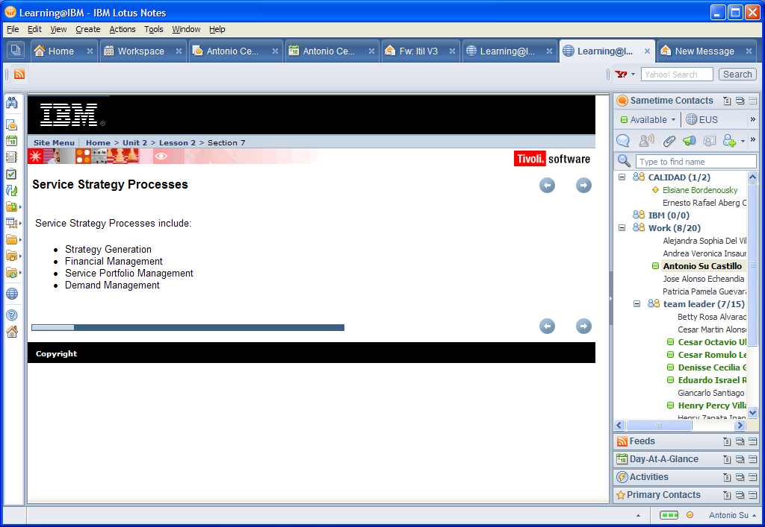

|  |  |
| --- | --- |
| Service Strategy Processes | [previous](https://w3-01.sso.ibm.com/learning/lms/content/content_store/cninv000000000027872/site/unit_2/lesson_2/sec06.htm)spacer[next](https://w3-01.sso.ibm.com/learning/lms/content/content_store/cninv000000000027872/site/unit_2/lesson_3/index.html) |

|  |
| --- |
| Service Strategy Processes include:   * Strategy Generation * Financial Management * Service Portfolio Management * Demand Management |
| Lesson 3: Strategy Generation | [previous](https://w3-01.sso.ibm.com/learning/lms/content/content_store/cninv000000000027872/site/unit_2/lesson_2/sec07.htm)spacer[next](https://w3-01.sso.ibm.com/learning/lms/content/content_store/cninv000000000027872/site/unit_2/lesson_3/sec01.htm) |

|  |
| --- |
| In this lesson, you will learn about the process of Strategy Generation and the activities and roles associated with Strategy Generation. |
| Strategy Generation | [previous](https://w3-01.sso.ibm.com/learning/lms/content/content_store/cninv000000000027872/site/unit_2/lesson_3/index.html)spacer[next](https://w3-01.sso.ibm.com/learning/lms/content/content_store/cninv000000000027872/site/unit_2/lesson_3/sec02.htm) |

|  |
| --- |
| To develop your service strategies:   * Differentiate your services from the competition. * Use existing opportunities: Customers who are not well-supported represent opportunities for services to be offered as solutions. * Use new opportunities: New opportunities emerge when changes in the business environment cause a previously well- supported customer to be poorly supported.   Defining the market and understanding the customer include the following activities:   * Service strategies are developed for services offered. * Providers differentiate their services from competing alternatives available to customers. * Service management offers services as part of a business strategy.   An example of market definition:  A software vendor decides to offer software as a service. The vendor combines the capabilities in software development with new capabilities in Service Management. The vendor also uses of the capabilities in maintaining software applications to bundle technical support as part of the core service. By adopting a service-oriented approach supported by Service Management capabilities, the vendor has transformed into a service business.  This approach has also been adopted by internal software engineering groups who have changed from being cost centers to being profit centers. |

|  |  |
| --- | --- |
| Main Activities of Strategy Generation | [previous](https://w3-01.sso.ibm.com/learning/lms/content/content_store/cninv000000000027872/site/unit_2/lesson_3/sec01.htm)spacer[next](https://w3-01.sso.ibm.com/learning/lms/content/content_store/cninv000000000027872/site/unit_2/lesson_3/sec03.htm) |

|  |
| --- |
| The main activities of Strategy Generation are:   * Define the Market * Develop Service Offerings * Develop Strategic Assets * Prepare for Implementation   ****Move the mouse pointer over each object in the following illustration for more detail.**** |

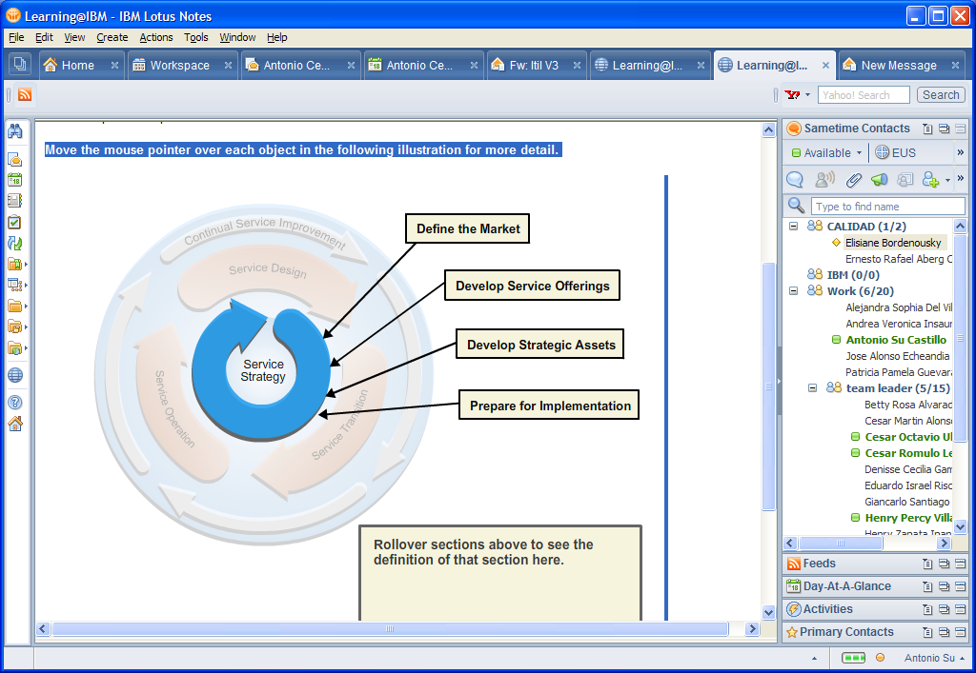

|  |
| --- |
| The Main Activities of Service Strategy Generation |

|  |
| --- |
| The Main Activities of the Service Strategy Generation process include defining the market, developing the service offerings, developing strategic assets, and preparing for implementation. The rollover image describes these sections in the following list:  **Define the market**   * Define the Market and Understand the Customer * Develop the Offerings and Strategic Assets   **Develop the service offerings**   * Service Portfolio (Concepts) * Service Portfolio Management (SPM)   **Develop strategic assets**   * Increasing Service and Performance Potential * Strategic Assessment * Setting Objectives * Defining Critical Success Factors * Expansion, Growth, and Differentiation   **Prepare for implementation**   * Concepts of the Service Catalog * Service Catalog Management * Service Catalog Management Outputs |
| Defining the Market: Market Space | [previous](https://w3-01.sso.ibm.com/learning/lms/content/content_store/cninv000000000027872/site/unit_2/lesson_3/sec02.htm)spacer[next](https://w3-01.sso.ibm.com/learning/lms/content/content_store/cninv000000000027872/site/unit_2/lesson_3/sec04.htm) |

|  |
| --- |
| Services are a means of delivering value to customers by facilitating outcomes customers need without owning specific costs and risks.  A ***market space*** is a set of opportunities to deliver value to the business of a customer through one or more services. To meet the needs of future opportunities, Service Management must further invest in assets such as process, knowledge, people, applications, and infrastructure.  A market space represents a set of opportunities for service providers to deliver value to the business of a customer through one or more services. Often it is unclear how services create value for customers. Services are often defined in the terms of resources made available for customers to use. Service definitions lack clarity on two points:   * Context in which such resources are useful * Business outcomes that justify the expense of a service from the customer perspective of the customer   This problem leads to poor designs, ineffective operation, and lackluster performance in service contracts. Service improvements are difficult when it is not clear what improvements are truly required. Customers can understand and appreciate improvements only within the context of their own business assets, performances, and outcomes. A correct definition of services takes into account the context in which customers perceive value from the services.  An outcome-based definition of services ensures that managers plan and implement all aspects of Service Management. These activities should be completed entirely from the perspective of what is valuable to the customer. Such an approach ensures that services not only create value for customers but also capture value for the service provider.  Solutions that facilitate or enhance the performance of the customer assets indirectly support positive outcomes generated by those assets. Such solutions and propositions hold utility for the business, when that utility is backed by a suitable warranty. |

|  |  |
| --- | --- |
| Expansion, Growth, and Differentiation | [previous](https://w3-01.sso.ibm.com/learning/lms/content/content_store/cninv000000000027872/site/unit_2/lesson_3/sec03.htm)spacer[next](https://w3-01.sso.ibm.com/learning/lms/content/content_store/cninv000000000027872/site/unit_2/lesson_3/sec05.htm) |

|  |
| --- |
| The best opportunities for service providers lie in areas where an important customer need remains poorly satisfied. Service portfolios should be extended to support such areas of opportunity. Usually there is a need for services to provide certain levels of utility and warranty. However, managers should not overlook the costs and risks in such areas. There are typically strong reasons why certain needs of customers remain unfulfilled. Breakthrough performance and innovation are typically required to successfully deliver value in underserved areas of opportunity.  The long-term vitality of the service provider rests on supporting customer needs as they change or grow and exploiting new opportunities that emerge. This analysis identifies opportunities with current and prospective customers. It also prioritizes investments in service assets based on their potential to serve market spaces of interest.  Because market spaces are defined in terms of the business needs of customers, service provider strategies are therefore aligned to customers. For this reason, service providers must think in terms of market spaces and not simply industry sectors, geographical areas, or technology platforms. This way of thinking is intuitive to the senior leadership of Type I providers. They are accustomed to being driven more by the outcomes expected by their business units than by the traditional market segmentation. When service strategies are linked to market spaces, it is easier to make decisions about service portfolios, designs, operations, and long-term improvements. Investments in service assets such as skills sets, knowledge, processes, and infrastructure are driven by the critical success factors for a given market space.  Strategic planning and review includes examining opportunities for growth within current customers and services. Growth in a market space is dependent upon demonstrated ability to deliver value and a strong record with existing customers.  Differentiation in market spaces is normally created by the following techniques: |

* A better mix of services
* Superior Service Designs
* Operational effectiveness that allows for efficiency and effectiveness in the delivery and support of services

Differentiation can be created in many ways with various combinations of factors. Service Management leads to differentiation in every supported market space by making decisions on the following topics:

* Service design
* Transition
* Operation
* Improvement

|  |  |
| --- | --- |
| Service Management as a Strategic Asset | [previous](https://w3-01.sso.ibm.com/learning/lms/content/content_store/cninv000000000027872/site/unit_2/lesson_3/sec04.htm)spacer[next](https://w3-01.sso.ibm.com/learning/lms/content/content_store/cninv000000000027872/site/unit_2/lesson_3/sec06.htm) |

|  |
| --- |
| Service management as a strategic asset identifies the key relationships and interactions to have better visibility and control over the systems and processes they operate.  Customers perceive benefits in a continued relationship and trust the provider to increase value and add possibilities of new customers and market spaces. These benefits justify further investments in Service Management in terms of capabilities and resources that have a tendency to reinforce each other. Stakeholders might initially trust the provider with low-value contracts or noncritical services.  Service Management responds by delivering the performance expected of a strategic asset. The performance is rewarded with contract renewals, new services, and customers. Together these rewards represent a larger value of business. To handle this increase in value, Service Management must invest further in assets such as process, knowledge, people, applications, and infrastructure. Successful learning and growth enables commitments of higher service levels as Service Management is conditioned to handle bigger challenges. Over time, this cycle results in higher capability levels and maturity in Service Management, leading to a higher return on assets for the service provider.  Unless properly defined, the cost of service assets spent in support of customers assets can be difficult to account for and recover. This difficulty leads to situations where adequate value is created for the customer, but inadequate value is captured for the provider.  To develop Service Management as a strategic asset, define the value network by identifying the key relationships and interactions. This definition will provide better visibility and control over the systems and processes they operate. Managers can manage the complexity of their business environments as customers pursue their own business models and strategies. Service Management also helps account for all the costs and risks involved in providing a service or supporting a customer.  Strategic assets are dynamic. They are expected to continue to perform well under changing business conditions and objectives of their organization. Therefore, strategic assets must have learning capabilities. Performance in the immediate future should benefit from knowledge and experience gained from the past. Service Management must operate as a closed-loop system that systematically creates value for the customer and captures value for the service provider. An important aspect of Service Management is controlling the interactions between customer assets and service assets. |

|  |  |
| --- | --- |
| Develop Strategic Assets by Increasing Service and Performance Potential | [previous](https://w3-01.sso.ibm.com/learning/lms/content/content_store/cninv000000000027872/site/unit_2/lesson_3/sec05.htm)spacer[next](https://w3-01.sso.ibm.com/learning/lms/content/content_store/cninv000000000027872/site/unit_2/lesson_3/sec07.htm) |

|  |
| --- |
| Service providers have capabilities and resources (service assets) that represent the service potential available to customers. Projects that develop or improve capabilities and resources increase the service potential.  The services offered by a service provider represent the potential to increase the performance of customer assets. Without this potential, customers cannot justify procuring the services. Performance potential of services needs to be defined so that management decisions are rooted in creating value for customers. This practice avoids many problems of service businesses where value for customers is created in intangible forms and is therefore harder to define and control. Working backwards from the performance potential of customers ensures that service providers are always aligned with business needs, regardless of how often those needs change.  The performance potential of services is increased primarily by having the right mix of services to offer to customers. Performance potential also includes being able to design those services to have an impact on the businesses of the customers.  The productive capacity of service assets is transformed into the productive capacity of customer assets. An important aspect of delivering value for customers through services is reducing risks for customers. By deciding to use a service, customers often are seeking to avoid certain risks and costs. Therefore, the performance potential of services also arises from removing costs and risks from the businesses of the customers. |

|  |  |
| --- | --- |
| Preparing for Implementation: Strategic Assessment | [previous](https://w3-01.sso.ibm.com/learning/lms/content/content_store/cninv000000000027872/site/unit_2/lesson_3/sec06.htm)spacer[next](https://w3-01.sso.ibm.com/learning/lms/content/content_store/cninv000000000027872/site/unit_2/lesson_3/sec08.htm) |

|  |
| --- |
| Established service providers frequently do not understand their unique differentiators. The differentiation can come in many forms:   * Barriers to entry, such as the knowledge of the organization regarding the business of the customer or the broadness of service offerings * Raised switching costs, due to lower cost structures generated through specialization or service sourcing * A particular attribute not readily found elsewhere, such as:   + Product knowledge   + Regulatory compliance   + Provisioning speeds   + Technical capabilities   + Global support structures |

|  |  |
| --- | --- |
| Preparing for Implementation: Setting Objectives | [previous](https://w3-01.sso.ibm.com/learning/lms/content/content_store/cninv000000000027872/site/unit_2/lesson_3/sec07.htm)spacer[next](https://w3-01.sso.ibm.com/learning/lms/content/content_store/cninv000000000027872/site/unit_2/lesson_3/sec09.htm) |

|  |
| --- |
| Objectives represent the results expected from pursuing strategies. Strategies represent the actions to be taken to accomplish objectives. Clear objectives provide for consistent decision making, minimizing any future conflicts. They set forth priorities and serve as standards.  To craft objectives, an organization must:   * Understand what outcomes customers want * Determine how best to satisfy the important but under served outcomes   From this understanding, the organization can create metrics to measure how well a service is performing. These data sources are the primary means by which a service provider creates value. |

|  |  |
| --- | --- |
| Preparing for Implementation: Defining Critical Success Factors | [previous](https://w3-01.sso.ibm.com/learning/lms/content/content_store/cninv000000000027872/site/unit_2/lesson_3/sec08.htm)spacer[next](https://w3-01.sso.ibm.com/learning/lms/content/content_store/cninv000000000027872/site/unit_2/lesson_3/sec10.htm) |

|  |
| --- |
| Every market space has critical success factors that determine the success or failure of a Service Strategy. These factors are influenced by customer needs, business trends, competition, regulatory environment, suppliers, standards, industry best practices, and technologies. Identifying critical success factors for a market space is an essential aspect of strategic planning and development. In each market space, service providers require a core set of assets in order to support a Customer Portfolio using a Service Portfolio. For example, in the market space for high-volume, real-time data processing, such as those required by the financial services industry, service providers must have:   * Large-scale computer systems * Highly reliable network infrastructure * Secure facilities * Knowledge of industry regulations   Without these assets, such service units cannot provide the utility and warranty demanded by customers in that market space.  The dynamic nature of markets, business strategies, and organizations requires critical success factors be reviewed periodically. In addition, significant events such as changes to customer portfolios, expansion into new market spaces, changes in the regulatory environment, and disruptive technologies need to be monitored. For example, the health care industry has new legislation on the portability and privacy of patient data. This change alters the critical success factors for all service providers operating in health care market spaces. |

|  |  |
| --- | --- |
| Strategy Generation Roles | [previous](https://w3-01.sso.ibm.com/learning/lms/content/content_store/cninv000000000027872/site/unit_2/lesson_3/sec09.htm)spacer[next](https://w3-01.sso.ibm.com/learning/lms/content/content_store/cninv000000000027872/site/unit_2/lesson_4/index.html) |

|  |
| --- |
| **IT Steering Group (ISG)**  The IT Steering Group (ISG) sets the direction and strategy for IT Services. It includes members of senior management from business and IT. The ISG reviews the business and IT strategies in order to make sure that they are aligned. It also sets priorities of service development programs and projects.  **Service Owner**  The Service Owner of each service record contains the role or function currently accountable for the service, but not for the Service Portfolio Management process.  **Service Sponsor**  The Service Sponsor is the person or board responsible for budgets and costs related to a specific service.  **Requirements Requester**  The Requirements Requester is the person or group of persons expressing new demands and requirements to be fulfilled by the IT service provider.  **Service Design Team**  The Service Design Team is the team associated to all tasks in the context of designing a service. This team is responsible for creating a Service Design Package. |

|  |  |
| --- | --- |
| Lesson 4: Service Portfolio Management | [previous](https://w3-01.sso.ibm.com/learning/lms/content/content_store/cninv000000000027872/site/unit_2/lesson_3/sec10.htm)spacer[next](https://w3-01.sso.ibm.com/learning/lms/content/content_store/cninv000000000027872/site/unit_2/lesson_4/sec01.htm) |

|  |
| --- |
| In this lesson, you will learn about the Service Strategy process of Portfolio Management. In addition, you will learn about the Service Catalog and Service Catalog Management. |

|  |  |
| --- | --- |
| Service Portfolio Defined | [previous](https://w3-01.sso.ibm.com/learning/lms/content/content_store/cninv000000000027872/site/unit_2/lesson_4/index.html)spacer[next](https://w3-01.sso.ibm.com/learning/lms/content/content_store/cninv000000000027872/site/unit_2/lesson_4/sec02.htm) |

|  |
| --- |
| The Service Portfolio represents the commitments and investments made by a service provider across all customers and market spaces. It represents present contractual commitments, new service development, and ongoing service improvement plans initiated by Continual Service Improvement. The portfolio also includes external vendor services, which are an integral part of service offerings to customers.  The Service Portfolio represents all the resources presently engaged or being released in various phases of the Service Lifecycle. Each phase requires resources for completion of projects, initiatives, and contracts. The phases are also an important governance aspect of Service Portfolio Management (SPM). |

### Process: Service Portfolio Management

### Service Portfolio contains elements of Service Design, CSI, Service Transition, and Service Operation.

The Service Portfolio represents all the resources presently engaged or being released in various phases of the Service Lifecycle. Entry, progress, and exit are approved only with approved funding and a financial plan for recovering costs or showing profit, as necessary.

The portfolio should have the right mix of services in the pipeline and catalog to secure the financial viability of the service provider. The Service Catalog is the only part of the Service Portfolio that recovers costs or earns profits. The Service Portfolio represents the commitments and investments made by a service provider across all customers and market spaces. It represents present contractual commitments, new service development, and ongoing service improvement programs initiated by Continual Service Improvement.

Service Portfolio Management (SPM) is about maximizing value while managing risks and costs. The value realization is derived from better service delivery and better customer experiences. SPM begins by documenting the standardized services of the organization and therefore has strong links to Service Level Management, particularly the Service Catalog.

Portfolio management helps managers prioritize investments and improve the allocation of resources. Portfolios instill a certain financial discipline necessary to avoid making investments that will not yield value. Service portfolios represent the ability and readiness of a service provider to serve customers and market spaces.

Through SPM, managers are better able to understand quality requirements and related delivery costs. They can then seek to reduce costs by alternative means while maintaining service quality. The SPM journey begins by documenting the standardized services of the organization and therefore has strong links to Service Level Management, particularly the Service Catalog.

|  |  |
| --- | --- |
| Service Portfolio Management Goals | [previous](https://w3-01.sso.ibm.com/learning/lms/content/content_store/cninv000000000027872/site/unit_2/lesson_4/sec02.htm)spacer[next](https://w3-01.sso.ibm.com/learning/lms/content/content_store/cninv000000000027872/site/unit_2/lesson_4/sec04.htm) |

|  |
| --- |
| The purpose of Service Portfolio Management is to create, manage and improve a service portfolio containing a detailed design package for each IT service.  Service Portfolio Management has the following goals:   * Every planned and operated service by the provider is documented. * Every new service must complete a set of standardized activities and procedures. * Essential information is documented and provided to the relevant management processes. * Each service and its design package is regularly reviewed. * Every service is reviewed within the Continual Service Improvement Process. * Through the service portfolio, an information base for a service catalog is provided. |

|  |  |
| --- | --- |
| Service Portfolio Management Benefits | [previous](https://w3-01.sso.ibm.com/learning/lms/content/content_store/cninv000000000027872/site/unit_2/lesson_4/sec03.htm)spacer[next](https://w3-01.sso.ibm.com/learning/lms/content/content_store/cninv000000000027872/site/unit_2/lesson_4/sec05.htm) |

|  |
| --- |
| A Service Portfolio describes the services of a provider in terms of business value. It outlines business needs and the response to those needs. By definition, business value terms correspond to marketing terms. Therefore, a Service Portfolio provides a means for comparing service competitiveness across alternative providers.  A Service Portfolio either clarifies or helps to clarify the following strategic questions:   * Why should a customer buy these services? * Why should they buy these services from us? * What are the pricing or chargeback models? * What are our strengths and weaknesses, priorities and risk? * How should our resources and capabilities be allocated?   Further benefits of Service Portfolio Management include:   * Helping managers prioritize investments and improve the allocation of resources. * Instilling financial discipline necessary to avoid making investments that will not yield value. * Representing the ability and readiness of a service provider to serve customers and market spaces. |

|  |  |
| --- | --- |
| Service Portfolio Management Activities | [previous](https://w3-01.sso.ibm.com/learning/lms/content/content_store/cninv000000000027872/site/unit_2/lesson_4/sec04.htm)spacer[next](https://w3-01.sso.ibm.com/learning/lms/content/content_store/cninv000000000027872/site/unit_2/lesson_4/sec06.htm) |

|  |
| --- |
| Service Portfolio Management includes the following activities:  **Define**  Collect information from all existing services as well as every proposed service. Every proposed service would include those in a conceptual phase. For example, all services the organization would provide if it had unlimited resources, capabilities and time. The purpose of this exercise is to understand the opportunity costs of the existing portfolio. A service provider needs to understand its limitations. In this way, it is better able to assess if it should keep doing what it is doing or reallocate its resources and capabilities.  **Analyze**  In this phase, the intent of the strategy is designed. During this activity, the following questions should be answered:   * What are the long term goals of the service organization? * What services are required to meet those goals? * What capabilities and resources are required for the organization to achieve those services? * What are the perspective, position, plan and patterns?   The answers to these questions guide the analysis and the desired outcomes of SPM. The ability to satisfactorily answer these questions requires the involvement of senior leaders and subject matter experts.  **Approve**  In this phase, deliberate approvals or disapprovals of the proposed portfolio take place. In addition, the corresponding authorization for new services and resources occurs in this phase.  **Charter**  In this phase decisions are communicated, resources are allocated, and services are chartered. This phase should begin with a list of decisions and action items. These are to be communicated to the organization clearly and unambiguously. These decisions should be correlated to budgetary decisions and financial plans. Budget allocations should enforce the allocation of resources. |
| Service Portfolio Management Roles | [previous](https://w3-01.sso.ibm.com/learning/lms/content/content_store/cninv000000000027872/site/unit_2/lesson_4/sec05.htm)spacer[next](https://w3-01.sso.ibm.com/learning/lms/content/content_store/cninv000000000027872/site/unit_2/lesson_4/sec07.htm) |

|  |
| --- |
| Service Portfolio Process Manager (Service Portfolio Manager) The Service Portfolio Process Manager manages the entire SPM process. This person is responsible for the effectiveness and efficiency of the SPM process. Service Portfolio Process Owner The Service Portfolio Process Owner is the Initiator of the process. This person is accountable for defining the strategic goals of the processes. In addition, this person is responsible for allocating all required process resources. Service Portfolio Management Team The members of this team are assigned to complete various activities in the SPM process. Service Agent The Service Agent of each service record contains the role or function responsible for the current activity or task within the process of Service Portfolio Management. The Service agent can be changed through a functional escalation, if allowed. This following role is assigned for each new instance of the Service Portfolio Management process and usually exist for the entire lifetime of one process instance. Changes in the assignment of this role is possible. However, the change applies only to a specific process instance, and not to the process in general. |

|  |  |
| --- | --- |
| The Service Catalog | [previous](https://w3-01.sso.ibm.com/learning/lms/content/content_store/cninv000000000027872/site/unit_2/lesson_4/sec06.htm)spacer[next](https://w3-01.sso.ibm.com/learning/lms/content/content_store/cninv000000000027872/site/unit_2/lesson_4/sec08.htm) |

|  |
| --- |
| The Service Catalog is an important tool for Service Strategy because it is the virtual projection of the actual service provider capabilities. Many customers are only interested in what the provider can commit now rather than in future. The value of future possibilities is discounted in the present. |
| This image illustrates the ITIL service catalog showing relationship between Product Manager, Service Catalog, and Relationship Manager. |

|  |  |
| --- | --- |
| Service Catalog Details | [previous](https://w3-01.sso.ibm.com/learning/lms/content/content_store/cninv000000000027872/site/unit_2/lesson_4/sec07.htm)spacer[next](https://w3-01.sso.ibm.com/learning/lms/content/content_store/cninv000000000027872/site/unit_2/lesson_4/sec09.htm) |

|  |
| --- |
| This image illustrates the Service Catalog details |

The Service Catalog is the subset of the Service Portfolio that is visible to customers. The Service Catalog:

* Consists of services presently active in the Service Operation phase and those approved to be readily offered to current or prospective customers.
* Is useful in developing suitable solutions for customers from one or more services.
* Contains items that can be configured and suitably priced to fulfill a particular need.
* Serves as a service order and demand channeling mechanism.
* Acts as the acquisition portal for customers, including pricing and service-level commitments, and the terms and conditions for service provisioning.

Providers might have many customers or serve many businesses. Therefore, the Service Portfolio might project multiple Service Catalogs. The Service Catalog expresses the operational capability of the provider within the context of a customer or market space.

The Service Catalog is the subset of the Service Portfolio that is visible to customers. The Service Catalog:

* Consists of services presently active in the Service Operation phase and those approved to be readily offered to current or prospective customers.
* Is useful in developing suitable solutions for customers from one or more services.
* Contains items that can be configured and suitably priced to fulfill a particular need.
* Serves as a service order and demand channeling mechanism.
* Acts as the acquisition portal for customers, including pricing and service-level commitments, and the terms and conditions for service provisioning.

Providers might have many customers or serve many businesses. Therefore, the Service Portfolio might project multiple Service Catalogs. The Service Catalog expresses the operational capability of the provider within the context of a customer or market space.

|  |  |
| --- | --- |
| Service Catalog Benefits | [previous](https://w3-01.sso.ibm.com/learning/lms/content/content_store/cninv000000000027872/site/unit_2/lesson_4/sec08.htm)spacer[next](https://w3-01.sso.ibm.com/learning/lms/content/content_store/cninv000000000027872/site/unit_2/lesson_4/sec10.htm) |

|  |
| --- |
| The Service Catalog has the following benefits:   * It is useful in developing suitable solutions for customers from one or more services. * Items in the Catalog can be configured and priced to fulfill a specific need. * It is the virtual projection of the actual and present capabilities of the service provider. * It serves as a service order and demand channeling mechanism. * It communicates and defines the policies, guidelines and accountability required for SPM. * It defines the criteria for what services fall under SPM and the objective of each service. * It is where assets, processes and systems are introduced with entry points and terms for their use and provisioning. |

|  |  |
| --- | --- |
| Service Catalog Management Activities | [previous](https://w3-01.sso.ibm.com/learning/lms/content/content_store/cninv000000000027872/site/unit_2/lesson_4/sec09.htm)spacer[next](https://w3-01.sso.ibm.com/learning/lms/content/content_store/cninv000000000027872/site/unit_2/lesson_4/sec11.htm) |

|  |
| --- |
| Service Catalog Management (SCM) process ensures that a Service Catalog is produced and maintained. In also makes sure that the Service Catalog contains accurate information about all operational services and those being prepared to be run operationally. SCM provides a single source of consistent information on all of the agreed-upon services. In addition, it ensures that the catalog is widely available to those approved to access it.  Service Catalog Management (SCM) performs the following activities:   * Manages the information contained within the Service Catalog * Ensures that the catalog is accurate * Ensures that the catalog reflects the current details, status, interfaces, and dependencies of all services that are being run or being prepared to run in the live environment   The Service Catalog provides a central source of information about the IT services delivered by the service provider organization. The catalog ensures that all areas of the business can view an accurate, consistent picture of the IT services, their details, and their status. The catalog should contain:   * View of the current IT services from the perspective of the customer * How the services are intended to be used * Business processes facilitated by the services * Levels and quality of service the customer can expect for each service * Details of all operational services being provided * Those services being prepared for transition to the live environment * Summary of their characteristics * Details of the customers   The portfolio should contain all of the future requirements for services. The Service Portfolio is produced as part of Service Strategy and should include participation by those involved in Service Design, Transition, Operation, and Improvement. After a service is chartered, being developed for use by customers, Service Design produces the specifications for the service. At this point the service should be added to the Service Catalog.  The SCM process produces and maintains the Service Catalog to ensure:   * A central, accurate, and consistent source of data * A record of the status of all operational services or services being moved to the live environment * A record of appropriate details of each service |

|  |  |  |  |  |
| --- | --- | --- | --- | --- |
| |  |  | | --- | --- | | Service Catalog Management Outputs and Inputs | [previous](https://w3-01.sso.ibm.com/learning/lms/content/content_store/cninv000000000027872/site/unit_2/lesson_4/sec10.htm)spacer[next](https://w3-01.sso.ibm.com/learning/lms/content/content_store/cninv000000000027872/site/unit_2/lesson_5/index.html) |  |  | | --- | | Many sources of information are relevant to the Service Catalog Management (SCM) process. These should include:   * Business information from the business and IT strategy, plans, and financial plans of the organization * Information on organizational current and future requirements from the Service Portfolio * Business impact analysis providing information on the impact, priority, and risk associated with each service or change to service requirements * Details of any agreed-upon, new, or changed business requirements from the Service Portfolio * The Service Portfolio * The Configuration Management System (CMS) * Feedback from all other process * Triggers for the SCM process, which are changes in the business requirements and services. One of the main triggers is a Request For Change (RFC). The Change Management process includes new services, changes to existing services, and services being retired.   The process outputs of SCM include the following items:   * The documentation and agreement of a definition of the service * Updates to the Service Portfolio, which should contain the current status of all services and requirements for services   The Service Catalog should contain:   * Details of every live service provided by the service provider or service being moved into the live environment * Current status of each of these services * Interface * Dependencies | | |
| Lesson 5: Financial Management | [previous](https://w3-01.sso.ibm.com/learning/lms/content/content_store/cninv000000000027872/site/unit_2/lesson_4/sec11.htm)spacer[next](https://w3-01.sso.ibm.com/learning/lms/content/content_store/cninv000000000027872/site/unit_2/lesson_5/sec01.htm) |

|  |
| --- |
| In this lesson, you will learn about the Financial Management Process |

|  |  |
| --- | --- |
| Financial Management Description | [previous](https://w3-01.sso.ibm.com/learning/lms/content/content_store/cninv000000000027872/site/unit_2/lesson_5/index.html)spacer[next](https://w3-01.sso.ibm.com/learning/lms/content/content_store/cninv000000000027872/site/unit_2/lesson_5/sec02.htm) |

|  |
| --- |
| Financial Management as a strategic tool is equally applicable to all three service provider types.  Financial Management consists of the function and processes responsible for managing an IT service provider's budgeting, accounting and charging requirements.  Internal service providers are increasingly asked to operate with the same levels of financial visibility and accountability as their business unit and external counterparts. Moreover, technology and innovation have become the core revenue-generating capabilities of many companies.  Financial Management quantifies, in financial terms, the value of IT Services and the assets underlying the provisioning of services. In addition, Financial Management provides the qualification of operational forecasting. A significant portion of Financial Management is working with IT and the business to identify, document, and agree on the value of the services being received. Financial Management also contributes to the ennoblement of service demand modeling and management. |

|  |  |
| --- | --- |
| Financial Management Goals and Benefits | [previous](https://w3-01.sso.ibm.com/learning/lms/content/content_store/cninv000000000027872/site/unit_2/lesson_5/sec01.htm)spacer[next](https://w3-01.sso.ibm.com/learning/lms/content/content_store/cninv000000000027872/site/unit_2/lesson_5/sec03.htm) |

|  |
| --- |
| Financial Management has the following goals:   * To ensure that management of IT Services are cost effective * To provide full accountability for IT Service expenditures to the services delivered to customers * To assist management in making decisions on IT investment by providing detailed business cases for changes to IT Services   Financial Management consists of the following benefits:   * Enhanced decision making * Speed of change * Service Portfolio Management * Financial compliance and control * Operational control * Value capture and creation |

|  |  |
| --- | --- |
| Financial Management Considerations | [previous](https://w3-01.sso.ibm.com/learning/lms/content/content_store/cninv000000000027872/site/unit_2/lesson_5/sec02.htm)spacer[next](https://w3-01.sso.ibm.com/learning/lms/content/content_store/cninv000000000027872/site/unit_2/lesson_5/sec04.htm) |

|  |
| --- |
| Financial Management needs to consider:   * Direct versus indirect costs * Labor costs * Variable cost elements * Translation from cost account data to service value   Direct costs are those that are directly attributable to a specific service. Indirect costs are those that are shared among multiple services. These costs should be analyzed to identify line items that should be maintained. The data available and the level of effort required should be considered in this decision.  Labor costs are another key expenditure requiring consideration. Analyzing labor costs can be difficult because of the complexity and accuracy of time tracking systems. Sometimes tracking labor resources assigned across services is not available. In this case, rules and assumptions must be created for allocation of these costs. In its simplest form, organizing personnel costs across financial centers based on a service orientation is a viable method for aligning personnel costs to services.  Variable cost elements include expenditures that are not fixed. They vary depending on factors such as the number of users or the number of running instances.  Translation from cost account data to service value is only possible after costs are attributed to services. Pricing the perceived value portion of a service involves analysis of historical costs, perceived value-added, and planned demand variances. |

|  |  |
| --- | --- |
| Financial Management Activity: Plan | [previous](https://w3-01.sso.ibm.com/learning/lms/content/content_store/cninv000000000027872/site/unit_2/lesson_5/sec03.htm)spacer[next](https://w3-01.sso.ibm.com/learning/lms/content/content_store/cninv000000000027872/site/unit_2/lesson_5/sec05.htm) |

|  |
| --- |
| Implementation of a Financial Management plan needs to include the following steps:   * Address critical questions about the business and IT culture * Assess the corporate culture and regulatory and compliance considerations * Identify all internal and external contacts that provide and receive IT financial information * Clarify IT and business expectations such as:   + deliverables   + chargeback system   + service catalog implementation and pricing * Determine systems that require Financial Management data * Determine the funding or operating model to be used * Assign responsibilities for the deliverables * Outline activities to be performed * Prepare the organization chart based on activities, size of data to be, and tools * Prepare policy and operating procedures list |

|  |  |
| --- | --- |
| Financial Management Activity: Analyze | [previous](https://w3-01.sso.ibm.com/learning/lms/content/content_store/cninv000000000027872/site/unit_2/lesson_5/sec04.htm)spacer[next](https://w3-01.sso.ibm.com/learning/lms/content/content_store/cninv000000000027872/site/unit_2/lesson_5/sec06.htm) |

|  |
| --- |
| To complete an analysis, the following steps should be completed.  Gather details around the planning and funding of identified items.   * The most detailed task will be analyzing the data pertaining to service valuation and demand modeling.   Make certain that all processes and information required to produce deliverables are accounted for.   * IT or the business might hold expectations regarding deliverables. Therefore, analyze backward to make certain all information required to produce the expected deliverables are accounted for. This process is part of Financial Management responsibilities.   Become familiar with current expenses in preparation for creating new valuation and funding documents.   * There might be issues that become apparent after reviewing expenditures. For example, it might become evident that not all IT payments are collected into one financial center. However, in order to report and account for services costs, IT expenditures must be centralized.   Perform service valuation after an accounting of all IT expenditures has been completed.   * Calculation of the value-add price will require a great amount of input from Service Level Management, Availability, Security and Capacity Management.   Adjust plans for implementation if necessary.   * If during the analysis phase it becomes apparent that Financial Management dependent processes are not available, the plans for implementation must be adjusted. For example, if no IT Services have already been identified, then valuation will be postponed. |

|  |  |
| --- | --- |
| Financial Management Activity: Design | [previous](https://w3-01.sso.ibm.com/learning/lms/content/content_store/cninv000000000027872/site/unit_2/lesson_5/sec05.htm)spacer[next](https://w3-01.sso.ibm.com/learning/lms/content/content_store/cninv000000000027872/site/unit_2/lesson_5/sec07.htm) |

|  |
| --- |
| The design phase creates the outputs that are expected from a Financial Management implementation. Working with key contributors and Service economics supporters is essential during this phase. Design is completed using data inputs and translations, reports, methodologies and models.  The design phase should consider the following factors:   * Processes * Valuation Models * Accounting processes * Chargeback methods * Procedures * Roles and responsibilities |

|  |  |
| --- | --- |
| Financial Management Activities: Implement and Measure | [previous](https://w3-01.sso.ibm.com/learning/lms/content/content_store/cninv000000000027872/site/unit_2/lesson_5/sec06.htm)spacer[next](https://w3-01.sso.ibm.com/learning/lms/content/content_store/cninv000000000027872/site/unit_2/lesson_5/sec08.htm) |

|  |
| --- |
| The implement phase includes activation of planned processes. The input initially comes from corporate financial systems and Change Management processes.  The measurement phase includes the following activities:   * Provide measures of success on financial trends within funding, valuing and accounting * Audit for any credibility gap between the value being received and price being paid * Perform regular audits   Auditing provides verification that processes are being followed. |

|  |  |
| --- | --- |
| Financial Management Inputs and Outputs | [previous](https://w3-01.sso.ibm.com/learning/lms/content/content_store/cninv000000000027872/site/unit_2/lesson_5/sec07.htm)spacer[next](https://w3-01.sso.ibm.com/learning/lms/content/content_store/cninv000000000027872/site/unit_2/lesson_5/sec09.htm) |

|  |
| --- |
| Service Valuation Financial Management collects data inputs from across the enterprise. It uses this data to assist in generating and disseminating information as an output. This information feeds critical decisions and activities such as service valuation. Service Valuation quantifies, in financial terms, the funding sought by the business and IT for services delivered, based on the agreed value of those services. Financial Management calculates and assigns a cost value to a service or service component. Then, they can be disseminated across the enterprise once the business customer and IT identify what services are actually desired.  Service Valuation focuses on two key concepts: Provisioning Value and Service Value Potential. **Provisioning Value** is the actual underlying cost to IT related to provisioning a service. This cost includes both tangible and intangible elements. Input comes from financial systems, and consists of payment for actual resources consumed by IT in the provisioning of a service. **Service Value Potential** is the value added component based on customer perceptions of what it could achieve using its own assets against what the service organization can provide. Demand Modeling Through the application of Financial Management, the Service Catalog is able to provide customers with the capability to regulate their demand and prepare budgets. Demand modeling uses service oriented financial information with factors of demand and supply in order to model anticipated usage by the business, and provisioning requirements by IT. This is for identifying funding requirements, variations and drivers of those variations, and to assist in the management of service demand. In this context, inputs for managing service demand include pricing and incentive adjustments that are intended to alter customer consumption patterns. Service Provisioning and Optimization Financial Management provides key inputs for Service Provisioning Optimization (SPO). SPO examines the financial inputs and constraints of service components or delivery models to determine if alternatives should be explored relating to how a service can be provisioned differently to make it more competitive in terms of cost or quality. Planning Confidence Financial Management tries to ensure that the delivery and consumption of services receives appropriate funding. Financial Management Planning focuses on demand and supply variances resulting from business strategy, capacity inputs and forecasting. It does not focus on individual line item expenditures or business cost accounts. As with planning for any other business organization, input should be collected from all areas of the IT organization and the business. The financial requirements act as inputs to critical business decision making. Service Investment Analysis The objective of service investment analysis is to derive a value indication for the total lifecycle of a service based on:   * the value received * costs incurred during the lifecycle of the service   In Service Investment Analysis, it is best to use an exhaustive inventory of assumptions rather than a limited set of high-level inputs, in order to generate a more realistic and accurate view of the investment being made. Accounting Financial Management works with corporate financial systems and service management. This type of service oriented accounting provides far greater detail regarding service provisioning and consumption. In addition, it results in generation of data that feeds directly into the planning process. The functions and accounting characteristics that occur include:   * Service recording: The assignment of a cost entry to the appropriate service. * Cost types: The higher level expenses categories such as hardware, software, labor, and administration. * Cost classifications: The classifications within services that designate the end purpose of the cost. Classifications include:   + Capital or operational: This classification addresses different accounting methodologies that are required by the business and regulatory agencies.   + Direct or indirect: This designation determines whether a cost will be assigned directly or indirectly to a consumer or service.     - Direct costs are charged directly to a service since it is the only consumer of the expense.     - Indirect or shared costs are allocated across multiple services since each service can consume a portion of the expense.   + Fixed or variable: This segregation of costs is based on contractual commitments of time or price.   + Cost units: This is the identified unit of consumption that is accounted for a particular service or service asset.  Compliance Compliance relates to the ability to demonstrate that proper and consistent accounting methods and practices are being employed. This relates to areas such as financial asset valuation, capitalization practices, revenue recognition, access and security controls. Variable Cost Dynamics Variable Cost Dynamics (VCD) focuses on analyzing:   * the many variables that impact service cost * how sensitive those elements are to variability * the related incremental value changes that result   Examples of components that could be used in analysis include:   * number and type of users * number of software licenses * cost or operating footprint of data center * delivery mechanisms * number and type of resources * the cost of adding one more storage device * the cost of adding one more user license |
| Financial Management Roles | [previous](https://w3-01.sso.ibm.com/learning/lms/content/content_store/cninv000000000027872/site/unit_2/lesson_5/sec08.htm)spacer[next](https://w3-01.sso.ibm.com/learning/lms/content/content_store/cninv000000000027872/site/unit_2/lesson_6/index.html) |

|  |
| --- |
| Financial Manager The Financial Manager is responsible for managing an IT service provider's budgeting, accounting and charging requirements. IT Financial Administrator The IT Financial Administrator is responsible for:   * gathering cost and budget data * administering financial reporting tools * maintaining cost models * assembling and producing financial reports |

|  |  |
| --- | --- |
| Lesson 6: Demand Management | [previous](https://w3-01.sso.ibm.com/learning/lms/content/content_store/cninv000000000027872/site/unit_2/lesson_5/sec09.htm)spacer[next](https://w3-01.sso.ibm.com/learning/lms/content/content_store/cninv000000000027872/site/unit_2/lesson_6/sec01.htm) |

|  |
| --- |
| In this lesson, you will learn about the Service Strategy process of Demand Management |

|  |  |
| --- | --- |
| Process: Demand Management | [previous](https://w3-01.sso.ibm.com/learning/lms/content/content_store/cninv000000000027872/site/unit_2/lesson_6/index.html)spacer[next](https://w3-01.sso.ibm.com/learning/lms/content/content_store/cninv000000000027872/site/unit_2/lesson_6/sec02.htm) |

|  |
| --- |
| One element of Service Management that cannot be ignored is Demand Management. Demand Management is important because customers don’t want to pay for unused resources. Although sometimes it is necessary to have surplus capacity to deliver service levels, unnecessary idle capacity can be avoided through correct Demand Management. In addition, inadequate capacity has an adverse effect on the quality and growth of delivered services. Therefore, it is essential that Demand Management techniques be used.  Demand Management includes techniques such as:   * Off-peak pricing * Volume discounts * Differentiated service levels   **Note**: Consumption and production produce demand in a highly synchronized pattern. The productive capacity of resources available to a service is adjusted according to demand forecasts and patterns. Some types of capacity can be quickly increased as required and released when not in use. The arrival of demand can be influenced using pricing incentives. However, it is not possible to produce and stock service output before demand actually materializes. |

|  |  |
| --- | --- |
| Activity-based Demand Management | [previous](https://w3-01.sso.ibm.com/learning/lms/content/content_store/cninv000000000027872/site/unit_2/lesson_6/sec01.htm)spacer[next](https://w3-01.sso.ibm.com/learning/lms/content/content_store/cninv000000000027872/site/unit_2/lesson_6/sec03.htm) |

|  |
| --- |
| Business processes are the primary source of demand for services. Patterns of business activity (PBA) influence the demand patterns seen by the service providers. It is very important to study the business activity of the customer to identify, analyze and codify such patterns. This will provide sufficient basis for Capacity Management. Examine the business activity and plans of the customer in terms of the demand for supporting services.  Business activities drive demand for services. Customer assets such as People, Processes, and Applications generate patterns of business activity (PBA). PBA define dynamics of a business and include interactions with customers, suppliers, partners and other stakeholders. Services often directly support PBA. Since PBA generate revenue, income and costs they account for a large proportion of business outcomes. Patterns of business activity (PBA) are identified, codified, and shared across process for clarity and completeness of detail.  One or more attributes such as frequency, volume, location and duration describe business activity. They are associated with requirements such as security, privacy and latency or tolerance for delays. This profile of business activity can change over time with changes and improvements in business processes, people, organization, applications and infrastructure. PBA are placed under change control.  Each PBA has to be substantially different from another PBA in order to be coded with a unique reference. Codifying patterns helps multidimensional analysis, using criteria such as likeness and nearness. This provides efficiency and robustness in developing a catalog patterns with simplification and standardization. This, in turn, reduces the number of patterns, makes analysis easier, and avoids complicated solutions. |
| Demand Management Goal and Benefits | [previous](https://w3-01.sso.ibm.com/learning/lms/content/content_store/cninv000000000027872/site/unit_2/lesson_6/sec02.htm)spacer[next](https://w3-01.sso.ibm.com/learning/lms/content/content_store/cninv000000000027872/site/unit_2/lesson_6/sec04.htm) |

|  |
| --- |
| Demand Management is a critical aspect of service management. Poorly managed demand is a source of risk for service providers because of uncertainty in demand.  The goal of demand management is to reduce cost and create value by being able to predict demand and reduce idle capacity.  The benefits of Demand Management include:   * Reducing cost generated by excess capacity * Creating value that provides a basis for cost recovery * Improving quality of services by reducing insufficient capacity * Reducing the uncertainty in demand but cannot entirely eliminate it * Influencing the arrival of demand in specific patterns using Demand Management techniques such as   + off-peak pricing   + volume discounts   + differentiated service levels * Predicting demand for services in the service catalog that support the process * Predicting demand for underlying service assets that support those services |

|  |  |
| --- | --- |
| Demand Management Activities | [previous](https://w3-01.sso.ibm.com/learning/lms/content/content_store/cninv000000000027872/site/unit_2/lesson_6/sec03.htm)spacer[next](https://w3-01.sso.ibm.com/learning/lms/content/content_store/cninv000000000027872/site/unit_2/lesson_6/sec05.htm) |

|  |
| --- |
| Activities for Demand Management include:   * Study the business of the customer to identify, analyze and codify patterns. The results will provide sufficient basis for Capacity Management. * Visualize the business activity and plans in terms of the demand for supporting services. * Identify, codify, and share patterns of business activity (PBA) across process for clarity and completeness of detail. * Construct user profiles (UPs) using one or more predefined PBA. UPs represent patterns that are persistent and correlated. * Associate each user profile (UP) with one or more PBA.   User profiles (UPs) are based on roles and responsibilities within organizations for people, and functions and operations for processes and applications. Business processes and applications are treated as users in many business contexts. Many processes are not actively executed or controlled by staff or personnel.  Process automation allows for processes to consume services on their own. Processes and applications can have user profiles.  You construct user profiles using one or more predefined PBAs UPs represent patterns that are persistent and correlated |

|  |  |
| --- | --- |
| Demand Management Interfaces | [previous](https://w3-01.sso.ibm.com/learning/lms/content/content_store/cninv000000000027872/site/unit_2/lesson_6/sec04.htm)spacer[next](https://w3-01.sso.ibm.com/learning/lms/content/content_store/cninv000000000027872/site/unit_2/lesson_7/index.html) |

|  |
| --- |
| Some of the benefits for analyzing PBA are in the form of inputs to service management functions and processes such as:   * Service Design can then optimize designs to suit demand patterns * Service Catalog can map demand patterns to appropriate services * Service Portfolio Management can approve investments in additional capacity, new services, or changes to services * Service Operation can adjust allocation of resources and scheduling * Service Operation can identify opportunities to consolidate demand by grouping closely matching demand patterns * Financial Management can approve suitable incentives to influence demand |

|  |  |
| --- | --- |
| Unit 2 Scenario | [previous](https://w3-01.sso.ibm.com/learning/lms/content/content_store/cninv000000000027872/site/unit_2/lesson_6/sec05.htm)spacer[next](https://w3-01.sso.ibm.com/learning/lms/content/content_store/cninv000000000027872/site/unit_2/review.htm) |

|  |
| --- |
| In the scenario for Unit 1, the creation of a service was described. Then it was indicated that the service exists inside a Service Catalog.  Unit 2 discussed the details of why a Service Catalog and services exist. In addition, it focused on the strategic approach and the theoretical approach to the service delivery of those services.  For this scenario, company X has decided to bring ITIL concepts and guidelines into its organization. Service Strategy makes an effective case for the delivery of IT as a service and for a strategic, analytical, and theoretical approach to such delivery.  An organization might ask where to start if it has never implemented any of the ITIL activities covered.  For an organization just starting on ITIL, it is often recommended that the business looks at the services there are to manage. In addition, the organization should obtain a solid grasp of what the business requirements are with respect to each of them.  To achieve this, a Service Catalog can be established. Eventually, the more comprehensive Service Portfolio of current, under development, and planned services, can be encompassed in the overall strategic approach to ITIL. Most organizations already are performing the services that will be identified for the catalog. They just need to develop the official offering. For example, the organization must decide whether the type of service provider the IT department is within the organization. (Definitions were reviewed in Lesson 2.) In addition, the organization must determine the specifics in regards to utility and warranty. For example, what does the service do (utility) and how well does it do it (warranty)?  Unit 1 contained a service which was a request for a project or enhancement to applications maintained by internal or external development teams. It is fairly easy to document the utility and warranty of these services. However, determining elements such as the Delivery Model or Services Model can be more challenging. The organization can use co-sourcing, where a combination of in-sourcing and outsourcing is used to support the service for enhancements to applications. |

Unit Review

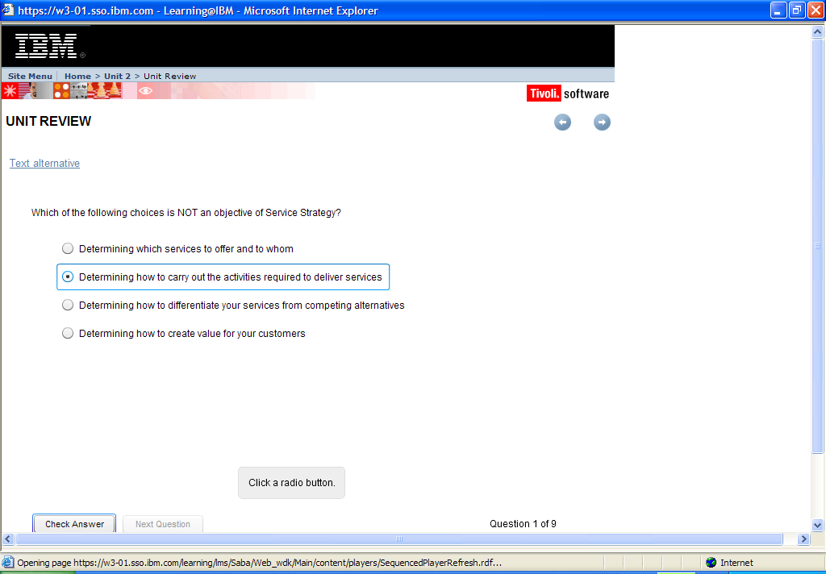

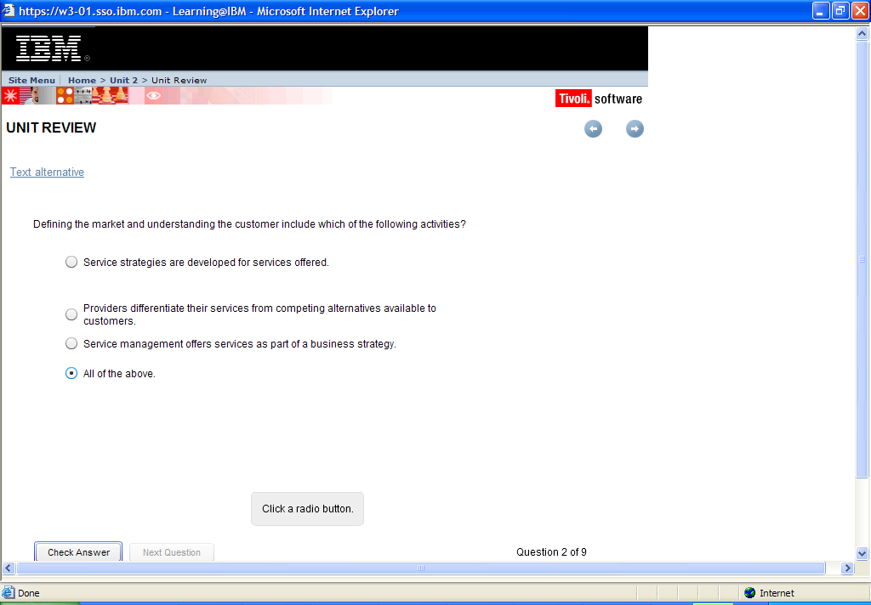

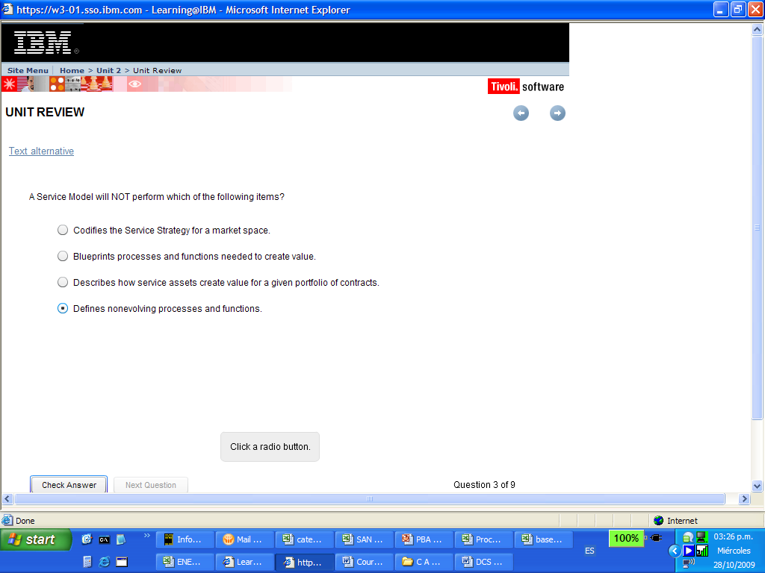

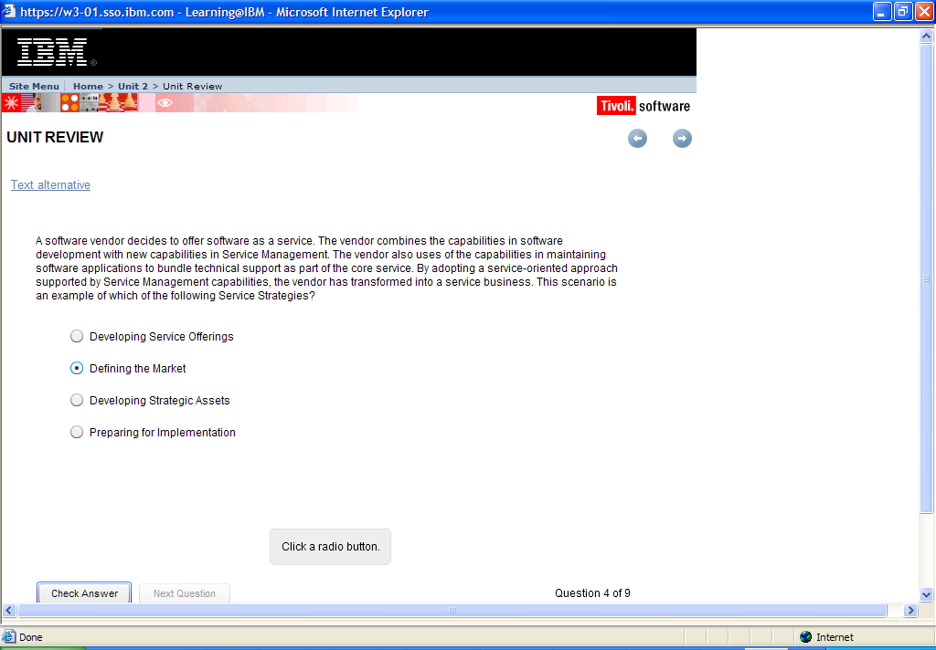

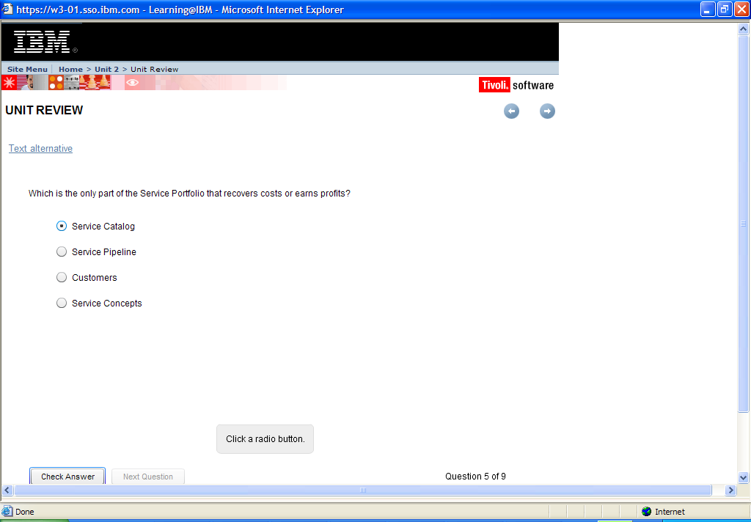

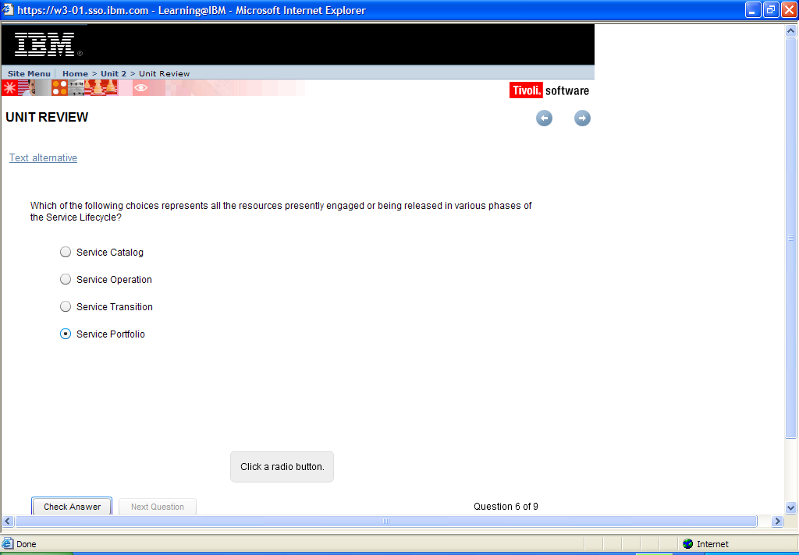

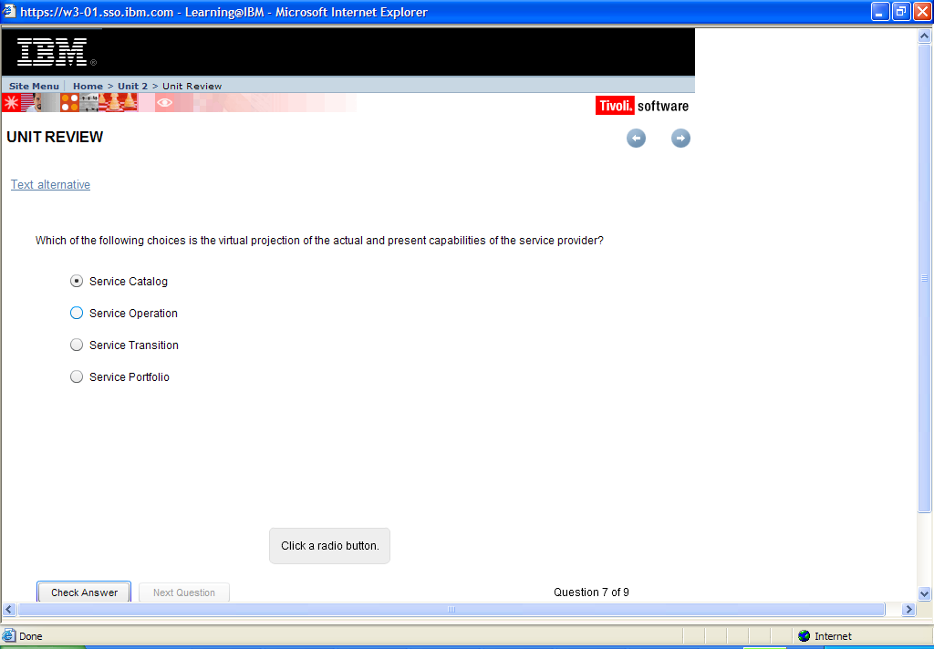

### 

### 

### 

|  |  |
| --- | --- |
| Unit Summary | [previous](https://w3-01.sso.ibm.com/learning/lms/content/content_store/cninv000000000027872/site/unit_2/review.htm)spacer[next](https://w3-01.sso.ibm.com/learning/lms/content/content_store/cninv000000000027872/site/unit_3/index.html) |

|  |
| --- |
| In this unit, you have learned how to:   * Explain the purpose of Service Strategy * Explain the two elements of value: utility and warranty * Describe the three types of service providers * Explain how to choose between service provider types * Describe the key principles of Service Strategy * Discuss the main Service Strategy processes and associated activities   If you feel that you need to review any part of this unit before continuing the course, take a moment at this time to return to the menu and navigate back to the appropriate section. |